ACTION HOPE-PREVAIL

OPORD

Operation Kujari Stabilisation

Wednesday, April 2nd 2008



Please be nice to me

**1. TASK ORGANISATION** **4**

**2. Situation** **5**

a) Area of Operations 5

i) Terrain 6

ii) Weather 7

b) Areas of Interest 7

i) Marwey Airfield 7

c) Enemy Forces 7

i) Composition, Disposition, and Strength 7

ii) Recent activities 7

iii) Enemy COAs 8

d) Friendly Forces 8

i) Higher HQ Mission and Intent 8

ii) Mission of Adjacent Units 8

e) Attachments and Detachments 9

f) Civil Considerations 9

**3. Mission** **9**

**4. Execution** **10**

a) Commander’s Intent 10

b) Concept of Operations 10

i) Manoeuvre 10

ii) Fires 10

iii) Reconnaissance and Surveillance 11

iv) Intelligence 11

c) Scheme of Movement and Manoeuvres 11

i) Route Clearance 11

ii) Consolidation Phase 11

iii) Phase 1 12

iv) Phase 2 12

d) Casualty Evacuation 13

e) Coordinating Instructions 13

i) Time or Coordination 13

ii) Rules of Engagement 13

**5. Sustainment** **14**

a) Logistics 14

i) Transportation 14

ii) Supply 14

b) Army Health System Support 14

i) Medical Treatment 14

**6. Command and Control** **15**

a) Signal 15

i) SOI Index in Effect 15

ii) Pyrotechnics and Signals 15

**7. Appendix/Glossary** **16**

# TASK ORGANISATION

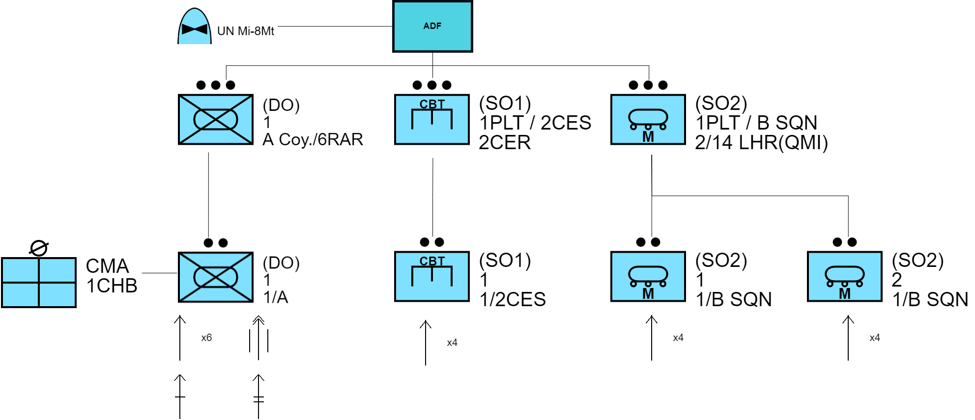

* 7th Brigade, 2nd Division, ADF | Callsign “EMU”
  + **1st Platoon, A Company, 6RAR - (DO)**
    - *1st Section, 1st Platoon, A Company* ***|*** *Callsign “SHIELD 1–1”*
    - *1x Combat Medical Attendant - 1 Close Health Battalion (Att)*
  + **10 Troop, 2nd Combat Engineer Squadron, 2nd Combat Engineer Regiment - (SO1)**
    - *1st Section, 2nd Combat Engineer Squadron* ***|*** *Callsign “FULCRUM 1–1”*
  + **1st Platoon, B Squadron, 2/14 Light Horse Regiment (Queensland Mounted Infantry) - (SO2)**
    - *1st Section, B Squadron* ***|*** *Callsign “RHINO 1–1”*
    - *2nd Section, B Squadron* ***|*** *Callsign “RHINO 1–2”*
* UN Aid Forces
  + Mi–8MT Transport Helicopter **|** Callsign “PARTRIDGE”

*All times used in the document are local time (GMT+1) unless stated otherwise.*

# Situation

## Area of Operations

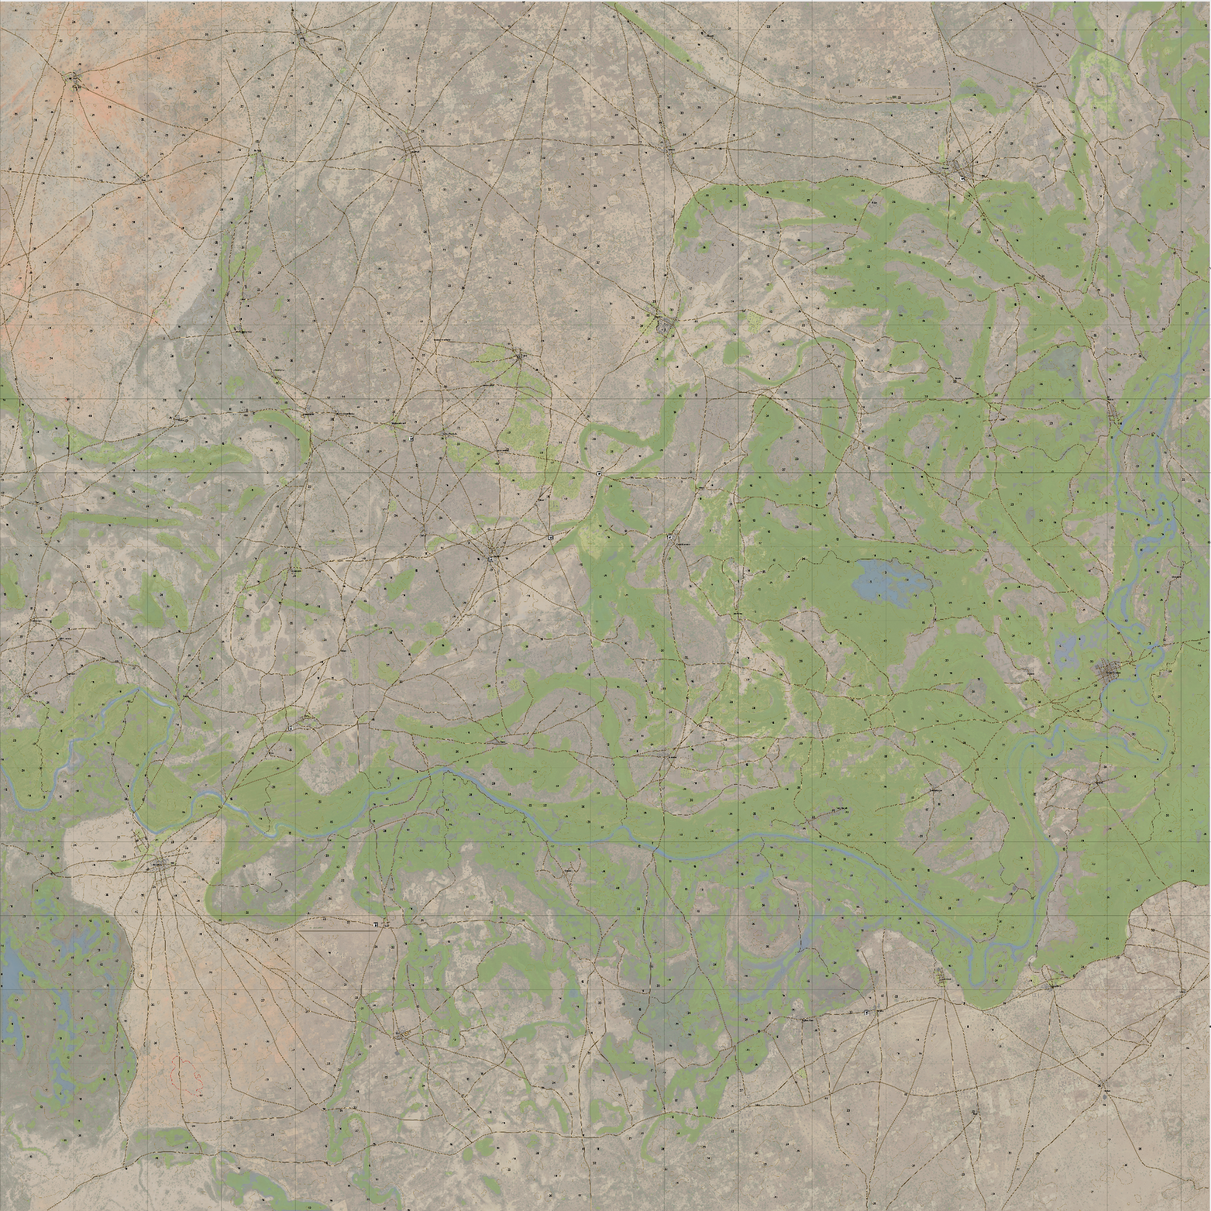  
Kujari -<https://jetelain.github.io/Arma3Map/kujari.html> 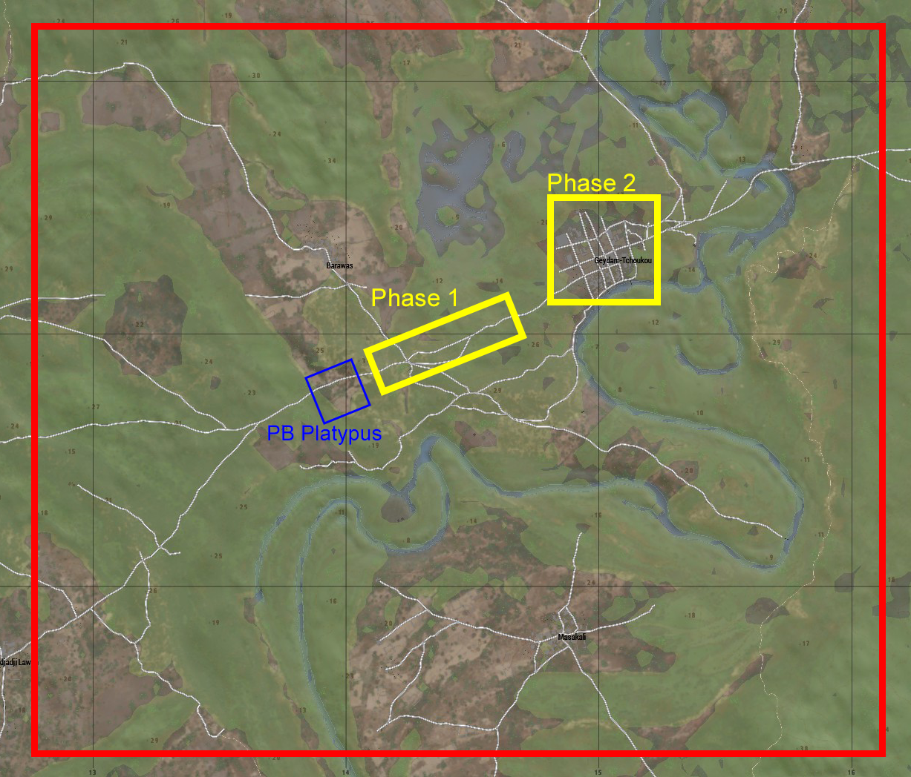  
Area of Operations

### Terrain

The Eastern region of Kujari is more densely vegetated than the Western and Northern regions of the country. This both aids and hinders friendly manoeuvres in the facets of cover, concealability, and freedom of movement. Low bushes and trees provide visual cover for enemy ambushes and IED placement along important routes and between locations.

The road between PB Platypus and the city of Geydam-Tchoukou is largely flat with low, wide hills that break up the terrain. The terrain rises before dipping into the opening that contains the city itself. The city backs onto a river, essentially blocking immediate inflow of enemies to the direct south.

The river that runs predominately North to South through the Area of Operations (AO), as well as waterways between them bear increased risk of exposure to potential dangers like wild boar, water buffalo, and more importantly crocodiles. If contact with wildlife occurs personnel are instructed **not** to fire at wildlife, but instead attempt to redirect troop movements to avoid them if possible. There have been few accounts of crocodile attacks in the region, but multiple sightings.

Due to the region being primarily farmland, many animals are accustomed to human contact. Animals may not give way to vehicles or foot traffic, and may instead continue their path unfazed. This further reinforces the necessity to avoid the fauna if possible, and move around them if not.

### Weather

The forecast for 0530 hours on Wednesday, 9 April, 2008 is 40% precipitation chance, 96% humidity, 30℃. Full moon will provide sufficient light until sunrise expected at 0545 hours local time. Fog is expected to be sparse providing high visibility in sufficient lighting.

High heat and humidity makes it necessary for each individual soldier to carry a **minimum** of 4.5L of water on their person, as well as additional water supplies in vehicles.

## Areas of Interest

### **Marwey Airfield**

MOB of UN and Australian peacekeeping forces.

* 1. **PB Platypus**

Patrol Base Platypus, primary operations location for the immediate area.

* 1. **Barawas**

Small village in close proximity of Geydam-Tchoukou, close to HLZ Kookaburra.

* 1. **Geydam-Tchoukou**

Capital city of Kujari, housing the primary hotel of the region.

* 1. **HLZ Hope**

Landing zone that must be secured for success of mission and allowance of medical resupply to the hospital.

## Enemy Forces

### Composition, Disposition, and Strength

Numbers and hostility of the KNFA have increased dramatically, with UN estimates of the force’s composition rising from 2000 in July of 2007 to 4200 in January of 2008. The insurgency controls approximately 87% of the nation, as well as a number of small cooperatives in surrounding areas.

60mm mortar systems have been recovered from KNFA locations in addition to expected small arms and improvised explosives. Reports have noted the increase in improvised technical vehicles being used by the KNFA.

### Recent activities

The KNFA have increased their violent actions on innocent civilians due to voicings of disagreements with the insurgency’s actions. Villages and UN contingencies in the area have reported mortar attacks preceding attacks by the KNFA. The use of expired, low quality, and home-made munitions in the mortar devices has led to a vast increase in unexploded ordnance (UXO) in the areas surrounding sites of attack.

The most recently reported KNFA mortar strike was in extremely close proximity to PB Platypus, between it and the city of Geydam-Tchoukou approximately 2 days ago on the 2nd of April, 2008. The inaccuracy of the force’s weapon system resulted in a majority of rounds landing on the primary transport route between the city and the patrol base. It is believed that the target of the strike was the hospital in the city proper, in an attempt to cut medical support from the UN and ADF forces from civilian access.

Due to the volume of UXO along the path to the city, the damage assessment of the hospital itself has been unable to be determined by ground forces, and the limited air tasking resources in the area have limited flyover times for helicopters, making it hard to fully assess the damage solely from helicopter flyovers.

### Enemy COAs

Contact with the enemy during this action is unanticipated. ISR has indicated the majority of KNFA activity in the recent 7 days to be concentrated in the further North–West of Kujari. Due to the insurgency consisting of locals, their movement is easily concealed by ISR, making it difficult to pinpoint their location and activity concentration.

If contact is made with the enemy it is predicted to be along the route where the platoon is conducting ordnance clearing. This is due to the vulnerability and high chance of unintended detonation if the platoon takes contact during this time. It is unexpected that the platoon will take contact in the town of Geydam-Tchoukou as it is a far less logical point of attack than the route between the town and PB Platypus; or the patrol base itself, it being open and inaccessible.

## Friendly Forces

### Higher HQ Mission and Intent

7th Brigade, being tasked with the neutralisation and peacekeeping of Kujari, has identified the hospital in the city of Geydam-Tchoukou as a key strategic position, necessary to the inflow and sustainment of medical aid and supplies to the civilian populace of the nation. The primary intent of higher HQ is to secure this position, and assess damage to facilities to persist the momentum of peacekeeping in the area.

### Mission of Adjacent Units

3rd Platoon, D Coy. of 6RAR is stationed in the far North-West of Kujari attempting to halt the importation of weapons and explosives, as well as the exportation of narcotics from the KNFA to fund their operations. This platoon is stationed at FOB Pyramid near the village of Biri Boula. FOB Pyramid also hosts two S-70A-9 Blackhawks from A Squadron, 5 Avn Regt, as well as a platoon sized element from 1CHB.

The supplied UN Mi-8MT helicopter tasked with transportation of the platoon element is also tasked with the responsibility of transporting aid supplies to the three transportation HLZs throughout the main element’s COA. This provides the possibility of reinforcement inserts to the AO. The delivery tasking of the helicopter consists of:

* 2x Food Supply Crates (Cardboard) to HLZ Kookaburra
* 2x Building Supply Crates (Netted Boxes) to HLZ Magpie
* 10x Medical Supply Boxes (Small Cardboard Boxes) to HLZ Lorikeet

*PARTRIDGE* is **not** to take any supplies on board at the same time as important phases of ADF operations, this means their secondary tasking of delivery will not be in effect while transporting ground forces in the consolidation phase of ACTION Hope-Prevail.

## Attachments and Detachments

| Unit | Attachment |
| --- | --- |
| 6RAR Section | 1CHB Combat Medical Attendant |
| 6RAR Section | Eastern Post News Journalist Crew |
| 2/14 LHR Section | 6RAR Section and Attachments |
| 2/14 LHR Section | 2CER Section |

## Civil Considerations

The only area in proximity to the city of Geydam-Tchoukou is the village of Barawas. It is understood that the majority of civilians living in or directly around Geydam-Tchoukou moved or evacuated after the recent mortar barrage. For this reason civilian presence in the city proper of Geydam-Tchoukou is unexpected, easing operations

# Mission

A mixed platoon element consisting of sections from 6RAR and 2CER will accompany two ASLAVs from 2/14 LHR on a route clearance marking exercise from the point of PB Platypus to the city of Geydam–Tchoukou NLT 0530 hours April 9, 2008. After the route is secure for travel, the platoon element will clear the town of Geydam-Tchoukou to confirm or deny enemy presence, and secure the landing site HLZ Hope for the landing of a UN operated Mi-8MT before finalising damage assessment of the town and hospital building.

# Execution

## Commander’s Intent

The intent of Action Hope Enduring is to secure the main transportation route between PB Platypus and the town of Geydam-Tchoukou which houses the primary hospital for the region. This action will allow the inflow of necessary medical supplies to the region as well as appropriate medical aid for the local populace.

Success will be decided by effective marking for clearance of UXO and hostile planted explosives along the main supply route between the town and PB Platypus, as well as the confirmation or denial of any hostile personnel within the town and immediate areas.

## Concept of Operations

### Manoeuvre

Ground units will be accompanied by the two ASLAVs supplied and accompanied by 2/14 LHR for additional security along their route clearance action. As vehicles cannot travel directly through the route in its current state, the armoured vehicles must remain behind the 2CER section as they clear ordnance as the lead element.

Transportation from Marwey Airfield to the primary AO is conducted by a United Nations provided Mi-8MT helicopter. The aircraft is permitted to fly at its own discretion to and from the HLZ under its own tasking, which may be utilised by friendly elements for transport and assistance.

### Fires

The fire elements in possession of each element are as follows.

* 1st Section, 1PLT, A Coy, 6RAR:
  + 6x F88 rifles
  + 1x F89 Light Support Weapon
  + 1x MAG58 Medium Support Weapon
  + 1x M72 Light Anti-tank Weapon (LAW)
* 1st Section, 10 Troop 2CES, 2CER:
  + 4x F88 Rifles
  + 3x Explosive Charges
* 1st Section, 1PLT, BSQD, 2/14 LHR
  + 1x ASLAV
    - 2x 7.62 MAG58 MSW
    - M242 25mm Bushmaster HSW
  + 3x F88 Rifles
* 2nd Section, 1PLT, BSQD, 2/14 LHR
  + 1x ASLAV
    - 2x 7.62 MAG58 MSW
    - M242 25mm Bushmaster HSW
  + 3x F88 Rifles

Units from 2CER are permitted a **maximum** **of two** (2) controlled detonations in the route clearance action. These controlled detonations are to be used for un-manouvrable route blockages, or UXO or IEDs in positions that greatly hinder platoon movements.

### Reconnaissance and Surveillance

No formal reconnaissance has been conducted in the immediate area since March 15th of this year. Due to the high activity and aggression in the North-West of the country, ISR resources have been prioritised to the movement of forces in that vicinity. However, local informants have indicated movements of enemy forces have increased in the area in recent days.

### Intelligence

In depth intelligence operations will not be conducted prior to this action, priority tasking to these elements is dedicated to the North-West region of the country.

## Scheme of Movement and Manoeuvres

### **Route Clearance**

Route clearance is to be conducted **only** by qualified personnel from the attached 2CER section. Mine detectors are supplied to sappers for detection and identification of UXO or IEDs. Engineer personnel are also to utilise coloured marking flags to indicate the position of explosives along the designated route. Red flags mark dangerously close proximity to explosives, warning a high risk of detonation. Yellow flags mark relative proximity to explosives, and green flags indicate the clearance range of the explosive, in which vehicles and personnel can pass safely.

Sappers are not permitted to attempt disarming or disposal of active explosives during this route clearing action and are only to mark their position to be cleared later. The priority of this action is to mark a clear path to allow transport through to the Phase 2 objective. A **maximum** of two (2) controlled detonations are permitted during the action and it is recommended these are reserved for significant blockages or unavoidable instances of UXO or IEDs.

### **Consolidation Phase**

Beginning at 0430 hours 1*st Section, 1st PLT D Coy, 6RAR | Callsign “SHIELD”* and *1st Section, 10 Troop 2CES, 2CER | Callsign “FULCRUM”* will begin preparation of equipment and weapon systems at Marwey Airfield before boarding the UN supplied Mi-8MT transport helicopter | *Callsign “PARTRIDGE”*.

At this point *PARTRIDGE* will dustoff from Marwey Airfield, heading South towards *Patrol Base Platypus*. During this transit time, elements from *B SQD, 2/14 LHR | Callsign “RHINO”* will begin preparation of equipment and weapons systems.

After *PARTRIDGE* reaches one of three designated HLZs of *HLZ Kookaburra, HLZ Magpie,* and *HLZ Lorikeet*, *SHIELD* and *FULCRUM* elements will move inwards on foot towards *PB Platypus*. Once ground elements achieve *PB Platypus*, *SHIELD* will call to *PARTRIDGE* to confirm consolidation of forces. After consolidation has been achieved, ground forces will step off in commencing Phase 1 NLT 0530 hours.

### **Phase 1**

At 0530 hours, ground forces will move East-North-East along the route marked Phase 1on the Area of Operations Map. *FULCRUM* will move ahead of formation using hand-held mine detectors in an attempt to identify and locate any unexploded ordnance or improvised explosive devices. *SHIELD* will accompany ASLAVs from *RHINO* along the designated route providing additional security and observation capabilities. All units are to diverge **no more** than 10 metres from the designated route at any time during Phase 1 of operations. This is to ensure the safety and security of personnel.

If at any point contact is taken along the route clearance, units **must** not advance further than the farthest identified and marked explosive, and must not deviate from the path more than 10 metres.

Phase 1 will be considered successful when the platoon element reaches the extents of the Phase 2 marked area.

### **Phase 2**

After completion of Phase 1, unit tasking is to be reassigned to move East towards the hospital in the town of Geydam-Tchoukou while also conducting hasty searches through buildings for civilian casualties affected by the aforementioned mortar strikes. Casualties should be treated where they are found if possible, otherwise consolidated on a casualty collection point (CCP) designated by the attached CMA.

After town clearance is completed, all units will reconvene at the hospital proper to conduct damage assessment of the hospital building. If damage assessment of the hospital determines it is feasible for the building to continue being used, the designated signaller from *SHIELD* will contact *PARTRIDGE* and advise that they have achieved security of *HLZ Hope*. *PARTRIDGE* will then complete their current task before returning to Marwey Airfield to collect the necessary aid supplies for delivery to Geydam-Tchoukou. During *PARTRIDGE*’s transit the platoon element is tasked with maintaining security of the hospital and HLZ until *PARTRIDGE*’s arrival.

Phase 2 will be considered successful at the completion of aid supply delivery to *HLZ Hope*.

* + 1. **Phase 3**

After the completion of Phase 2 in Action Hope–Prevail, all action assigned units will conduct BDA and casualty assessment before returning to PB Platypus. After Action Review will be conducted with the platoon element upon return at PB Platypus.

Action Hope-Prevail will be considered successful upon the completion of all previous phases including marking of all UXO and IEDs along the primary transportation route between PB Platypus and Geydam-Tchoukou, the clearance and damage assessment of Geydam-Tchoukou, and the delivery of aid supplies from Marwey Airfield to the hospital in Geydam-Tchoukou. Mission failure is only described by catastrophic loss of friendly forces by either contact with the enemy, or unintended detonations of UXO and IEDs.

## Casualty Evacuation

The plan for medical and casualty evacuation remains the same through all phases of the action. Non-urgent casualties will be treated to the unit’s best effect and transported back on the same vehicle they were infilled with. In extreme emergencies it is possible that MEDEVAC or CASEVAC can be hailed from callsign PARTRIDGE at the nearest available HLZ.

## Coordinating Instructions

### Time or Coordination

Equipment of forces should be organised and units ready for transportation NLT 0530 hours. To ensure this, organisation and preparation will begin as early as 0430 hours. This provides sufficient time allocation to check equipment and weapons systems, conduct command briefs, and disseminate information.

### Rules of Engagement

* Australian Defence Forces have the right to **defend** themselves against **attacks or threats of attack**
* Hostile fire may be returned effectively and promptly to stop a hostile act
* If under attack by an unarmed party, hostile element, riot and/or mobs, Australian Defence Forces should use the **minimum force** necessary under the circumstances and **proportional** to the threat.
* Australian Defence Forces **may not** seize the property of others to accomplish their mission.
* Detention of civilians is **authorised** for security reasons or in self defence.

1. Australian Defence Forces are present for *peacekeeping* and are **not** at war.
2. Treat all persons with dignity and respect.
3. Use minimum force to carry out missions.
4. Always be prepared to act in self defence.

# Sustainment

## Logistics

### Transportation

Transportation for ground elements from Marwey Airfield to PB Platypus is provided by a UN-provided Mi-8MT helicopter, operated by UN pilots. After ground troops arrive at PB Platypus, soldiers not manoeuvring on foot are provided transport by the 2/14 LHR ASLAVs moving unilaterally with ground elements.

### Supply

The two ASLAVs deployed with callsign *RHINO* contain sufficient equipment for the execution of action, and sustainment in the case of conflict. Equipment contained in vehicles consists of additional M72LAW Anti–Tank weapons, spare F88 Austeyr rifles, additional communication devices, medical supplies, water, hearing protection, EOD marking flags, lights, and ammunition for platoon weapon systems.

Soldiers equipped with the F88 Austeyr assault rifle are required to carry a **minimum** of 180 (6x 30 round magazines) rounds of ammunition on their person. MSW and LSW gunners are required to carry a **minimum** of 600 rounds (3x 200 round boxes or 4x 150 round boxes). Section leaders are **required** to carry a map and map tools on their person for land navigation.

## Army Health System Support

### Medical Treatment

There is 1 (one) combat medical attendant (CMA) attached from 1st Close Health Battalion (1CHB) in charge of the platoon’s health and casualty triage. The CMA is responsible for their own equipment and medication supplies to provide sufficient care to combatant and noncombatant individuals. New equipment may be provided to sections upon request of the platoon CMA to ensure there is an available readiness. If an individual is injured they should practise SOPs and provide self aid to the best of their abilities.

# Command and Control

## Signal

### SOI Index in Effect

Section appointed signallers must have the correctly designated long range radio and monitor the command frequency of 30MHz at all times. Vehicles must consistently monitor both the command net at 30MHz, and the inter-vehicle net of 31MHz at all times.

| **Frequency** | **Use** |
| --- | --- |
| 30 | Command Net |
| 31 | Vehicle Net |
| 50 | Inter-Squad Net |
| 51 | Shield 1-1 Local Net |
| 52 | Fulcrum 1-1 Local Net |

### 

### Pyrotechnics and Signals

Signalling friendly positions, enemy positions, and others will be done primarily with coloured smoke. Red smoke will signify enemy positions, green smoke will signify friendly positions, purple smoke will signify extraction positions, and blue smoke will signify Casualty Collection Points (CCPs) if necessary.

# Appendix/Glossary

| Noted As | Intended Meaning |
| --- | --- |
| 1CHB | 1st Close Health Battalion |
| 2/14 LHR (QMI) | 2nd/14th Light Horse Regiment (Queensland Mounted Infantry) |
| 2CER | 2nd Combat Engineer Regiment |
| 2CES | 2nd Engineer Squadron |
| 5 Avn Regt | 5th Aviation Regiment. |
| 6RAR | 6 Battalion, Royal Australian Regiment |
| ADF | Australian Defence Force |
| AO | Area of Operations |
| ASLAV | Australian Light Armoured Vehicle |
| B SQN | B Squadron |
| BDA | Battle Damage Assessment |
| Btn | Battalion |
| CASEVAC | Casualty Evacuation |
| CCP | Casualty Collection Point |
| CMA | Combat Medical Attendant |
| COA | Course of Action |
| Coy. | Company |
| DO | Decisive Operations |
| HLZ | Helicopter Landing Zone |
| HQ | Headquarters |
| HSW | Heavy Support Weapon |
| IED | Improvised Explosive Device |
| ISR | Intelligence, Surveillance, Reconnaissance |
| KNFA | Kujari National Freedom Army |
| LAW | Light Anti-tank Weapon |
| LSW | Light Support Weapon |
| MEDVAC | Medical Evacuation |
| MOB | Main Operating Base |
| MSW | Medium Support Weapon |
| NLT | No Later Than |
| PB | Patrol Base |
| Plt. | Platoon |
| Regt, Reg. | Regiment |
| SO | Shaping Operations |
| SOI | Signal Operating Instructions |
| SOP(s) | Standard Operating Procedure(s) |
| UN | United Nations |
| UXO | Unexploded Ordnance |